**Module 6 Assignment — Module Five Project**

**Project: Project: Two Optimization Problems:   
(i) A Transshipment Problem   
(ii) A Risk Minimizing Problem**

ALY-6050 Module six Project

**Prepared by: Sarvesh Thorve**

**Email: throve.s@northeastern.edu**

**INTRODUCTION**

Quadratic programming:

Mathematical optimization techniques are used by quadratic programming to minimize the objective functions. The choice variables have a power of zero, one or two. The objective function can be bi-linear or second order polynomial terms where constraints are linear and can be of both types that is equalities and inequalities. Quadratic programming is widely used optimizing financial portfolios, performing least squares of regression method or to control the scheduling of chemical plants by using sequential quadratic programming.

Rockhill shipping and transport is a company that provides a logistics service to transport waste from one place to another. This company is seeking a contract that would help in transferring the waste which is hazardous from the six plants of a company called Chimotox, to three of the waste disposal sites. The transport cost is covered by the company and Rockhill must also be able look into ways that will reduce their cost and gain maximum profits, whether it be direct transport or by transporting to several different ports and the finally to the destinations. There are a few constraints that should be obeyed by the manager and then come to the conclusion.

The analysis for the transportation cost between each plants and waste disposal sites, number of barrels that will be dropped off at each of the plants and waste disposal sites and the maximum capacity is all taken into consideration. There is a limit of waste the disposal sites can also take at a time and this constraint is also take into consideration.

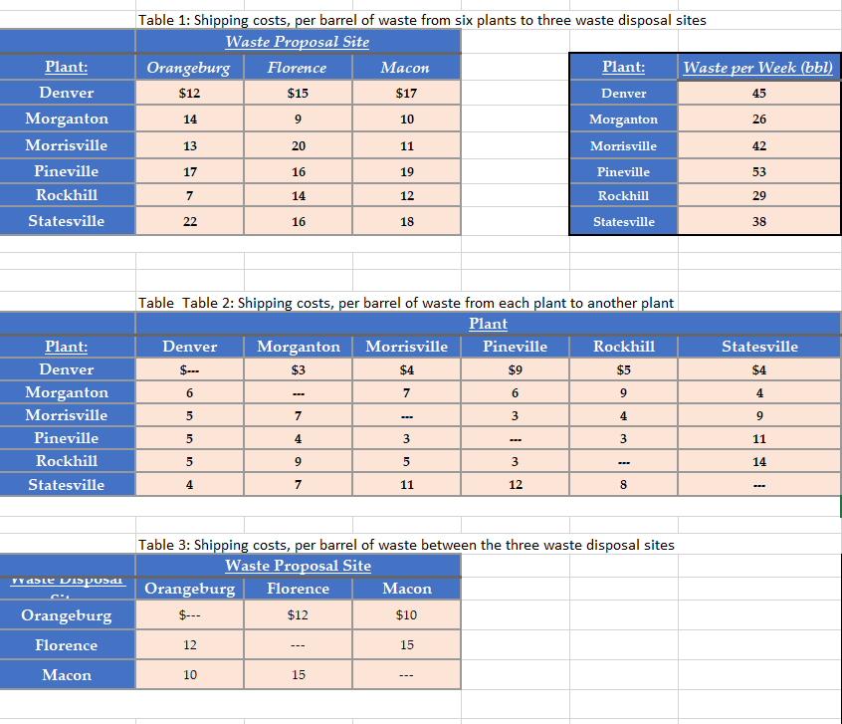

**ANALYSIS**

As we spoke about the plan that Rockhill manager would have to go with, there are a few constraints that he would want to abide by. We use the excel solver to find out the reduced cost for our project using the Simplex LP solving method.

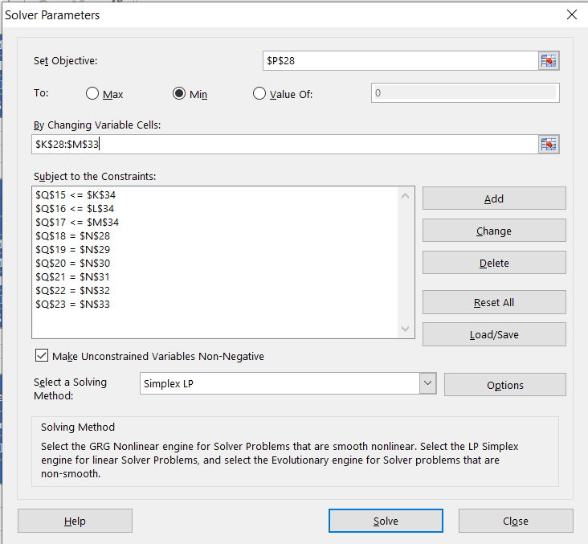

The shipping cost of per barrel from one plant to another and the shipping cost of waste disposal directly to the three disposal sites are mentioned too.

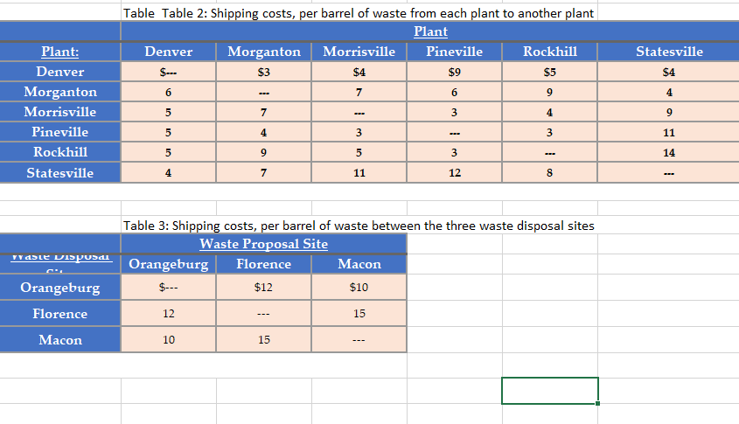

The transport of barrels provides the amount that is sent from the original place to the destination. There is capacity that tells us how many barrels can pass through at a point of given time according to the transportation schedule. The flow can be undertaken with an assumption that the barrels can be transported and stored within other plants or other disposal site.

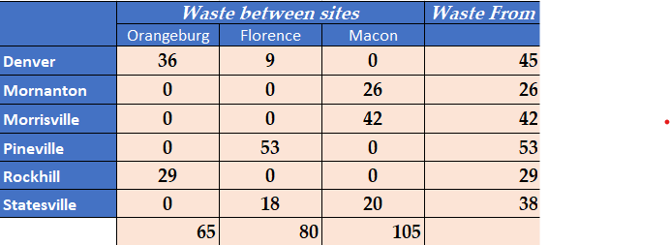

The table above tells us the distribution of waste between the sites and how much waste will be coming from each and every plant, keeping the constraint of the amount of waste each site can accept. It tells us that the waste sent from a particular plant gets distributed to different waste disposal sites in such a way that it keeps the constraints in place. Example the waste from Denver is been distributed in such a way 36 barrels goes to Orangeburg and 9 goes to Florence making a total sum of 45. We took the choice variable, all out costs which is then put in the solver .

The above detailed optimal routes would provide the least amount of total cost that Rockhill would have to incorporate in their proposal.

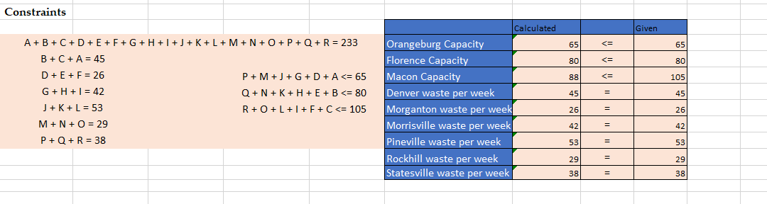

The constraints are been created from the given tables. We get these results after performing multiple combinations for 6 different plants and three different disposal sites, there are limitations of space, spending capacity, stock prerequisite. After meeting these limitations we come to a conclusion for the best possible option route for minimum cost.

After performing all these actions with constraints we get a reduced cost of $2988.



The solver tells us that the base cost of transportation for direct travel to the destination without any stops is $2988.

Now an arrangement should be decided on whether it is better to move the waste with no middle stops or the company can just dump the waste and then reload it again at various plants and waste areas.

The optimal solution that we get from the sensitivity report is a value of 88 barrels at the Macon Disposal site and its shadow price is also 0 and it has 0 reduced cost. This is the optimal solutions we were looking for.

We first entered the factors in general (option) in solver and then calculated the total expense cell. After that, I'll share all of the cutoff points together. The accompanying: utilized to make us feel obligated. The most important requirement is that the amount of admission or trash barrel transported corresponds to the amount of barrel transported. The corresponding sign for this requirement would be "=". The second would be the dumpsites' garbage extra room, which is depicted and located in the base lines.Finally, we calculate the Final Minimum Cost. I discovered a base with a transportation cost of $ 2674. According to the research, Morganton and Rockville are transitional plant focuses that are financially sound.

* Under the constraints of a limited budget, limited space, and a predetermined stock requirement, executives will seek advice on the amount of each item that will, in the end, yield the most significant benefits. Chief executives will also need to decide quickly whether to increase the budget or lease a larger distribution center in order to increase revenue. We'll create a direct programming model as well as an awareness report to address the problem. We'll also use the while circle to respond to questions about the gathering's budget.
* According to the appraisal, almost all of the trash generated in each factory during the week will be transported to disposal places. The total number of barrels that will be sent to the accompanying locations will range from 62 to Morganton, 36 to Rockhill, and 65, 80, and 88 to Orangeburg, Florence, and Macon, respectively.
* Based on the findings of the previous analysis, we can conclude that the steering route, in which barrels are taken off and dropped off at various manufacturing plants and rubbish locations, is preferable to direct travel because the total cost in the latter circumstance is the lowest.
* Two different approaches were used in the aforesaid inquiry for part 1. The transfer of waste from plants to rubbish disposal places was determined in the first method. The chief selected to relocate the loss to various spots between middle places in the following approach. The starting cost for using method 1 was $2988. In most cases, using the following methods, the lowered cost of the event was $2674. According to the findings, Rockhill's administrator, Allen, should consider implementing the following methods and transporting waste through several transitional locations in the middle.

**Part 2**

**Investment Allocations:**

The various resource categories that financial backers have chosen for their portfolios are listed below. The rate of return esteem in this table is calculated using data.

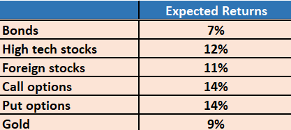

The covariance lattice of the benefits available to financial backers for each resource is shown in the table below. Non-inclining demonstrates the covariances between the two resources, while every slanting addresses a change of resource.

The profit covariance framework for resources is shown in the table above. The meaning of the covariance framework is that components with considerable slanting handle resource fluctuation, whereas non-corner to corner components address the Covariance between any two resources available. The following is the covariance framework. The framework only populates the upper triangle with belief, indicating that the covariance network is generally symmetric.

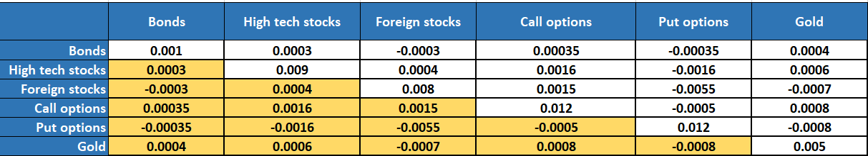

Then, for each product in his portfolio, we should process the expenditure designation. The main goal is to have an acceptable and lower-than-average rate of return of 11%.

To begin, we create a model in which the decision factors are each of the portfolio's resources. Then, at that time, we calculated the rate of return by combining the rate of return of each resource by its choice variable. I devised an equation to determine the variation or risk. I used Excel's MMULT function to compute the venture's base gamble for this computation. We used the solver for the GRG-procedure after entering all of the criteria to find the ideal least gamble for a standard normal return of 11%.

In light of the composite, appraisals are 0.0074, implying a usual return of 11%.

In the table below, I calculated the percentage contribution for each item if a single person chooses to contribute $100,000.

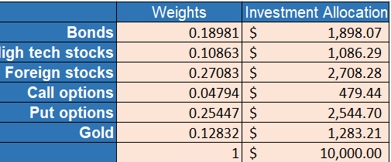

Finally, we can see from the table that the best distribution will benefit the unknown stock, while the financial supporter should only place 4.79 percent in call options to reduce risk.

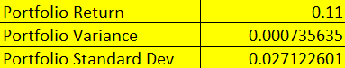

Use sequential amounts of 10%, 10.5 percent, 11 percent, 11.5 percent, 12 percent, 12.5 percent, 13 percent, and 13.5 percent as the basis return values to deliver eight sets of arrangements (r, e). Compare and contrast the letters "e" with "r."

To response to this inquiry, I immediately ran the solver for each expected pattern return listed in the table below. The least gamble used in each computation for a specific expected return is recorded below, based on the solver calculation. We can see a pattern here in the qualities: as the expected return increases, so does the gambling partner.

In this chart, we can observe that the appropriate bend and pattern appear between these two parameters. As the expected return rate rises, the gamble interface rises with it. As a result, we might infer that as we increase the portfolio's base rate of return, we should think twice about the risks associated with it.

As a result, I believe there must be a reasonable balance of expected return % and risk. The overall trendline in the accompanying diagram can also be seen.

The plot in the above visual show clearly shows that there is an example in the informational elements. The basic gamble related increases considerably as the portfolio return increases. If we handle this in numerical depth, the pattern will be similar to the following. y=0.0005e2225x and R = 0.9582, indicating that model is the best fit model because the RP esteem is extremely close to +1, indicating a strong positive association.

**CONCLUSION:**

We made two improvements to this work in order to reduce risk and cost.

We learned about the dominate solver in this work, which is a useful tool for simplifying. A dominating solver can be used to analyze and resolve minimization and expansion problems. I learned about portfolio executives, venture assignment, and how to process the best speculation apportioning based on the information provided via this activity. As the expected return increases, so does the risk involved. We can see that as we increase the portfolio's most un-base rate of return, we should adjust the gamble. As a result, there should be a good balance of rate of return percent and risk. After completing the aforementioned assessment, one can conclude that the steered path, in which barrels are picked up and dropped off at numerous offices and garbage locations, is more advantageous than straight travel because the overall cost in the latter circumstance is the lowest. It was then requested that the gamble for venture be limited between distinct aids in the following inquiry. With a $10,000 investment budget, $2778 should be allocated to bonds, $895 to high-tech stocks, 2919 to foreign stocks, $693 to call options, and $2713 to put options, assuming an 11 percent return on each resource. For this configuration, the determined least worth of risk is 0.000900041.

**REFERENCES:**

* *Excel solver - global optimization*. solver. (2015, April 7). Retrieved February 19, 2022, from <https://www.solver.com/excel-solver-global-optimization>
* *Quadratic Programming for portfolio optimization, problem-based*. Quadratic Programming for Portfolio Optimization, Problem-Based - MATLAB & Simulink. (n.d.). Retrieved February 19, 2022, from <https://www.mathworks.com/help/optim/ug/quadratic-programming-portfolio-optimization-problem-based.html>
* *Risk Management & Trading Psychology → Chapter 5*. (n.d.). Retrieved from https://zerodha.com/varsity/chapter/risk-part-4-correlation-matrix-portfolio-variance/
* BANTON, C. (2022, January 22). *Calculating Covariance for Stocks*. Retrieved from https://www.investopedia.com/articles/financial-theory/11/calculating-covariance.asp